**“Changing Political Orientations in Türkiye” Project**

**Written Report for CSSM 502**

Abdullah S. KÖŞGEROĞLU

1. **Research Question and Hypothesis**

Research purpose of this study is to measure and evaluate which political system Turkish people prefer to be ruled with, how their preferences changed over the course of time and which sociopolitical and legal developments affected these changes. To define what is meant by political system, scope of the research encompasses various liberal and authoritarian regimes such as pluralistic democracy, technocracy, military dictatorship, religious dictatorship and autocracy. The research question is aimed to be theoretical so that it does not get affected from short-term political fluctuations. The main object of the research is to analyze Turks’ long-term mentality changes against commonly held political periods so-called *political and economic crises* (1996-2001), *liberalization and economic growth* (2002-2012), *increasing authoritarianism and relatively stabilized economy* (2013-2017) and *the* *rule under the Presidential Government System and economic crisis* (2018-2023). Although there is no consensus on this periodization, the aim of this study is not proposing a new one. Rather, its aim is to analyze the reflection of the developments in these periods on people's mentalities[1] and conducting better analyses by covering all the data from these different periods[2]. In addition to that, measuring the effect of independent variables (e.g., age, political orientation, religiosity, income level and others) on the dependent variable is also aimed to understand the dynamics of the change.

This project relies on the discussions about so called “democratic backsliding” phenomenon, which will be detailed in the literature research section. Although democratic backsliding as a global trend is commonly said to be valid for Türkiye, the hypothesis of this project is to observe a rise in democratic values mainly because of its local features as a developing country. Also, a democratic backlash against the last constitutional amendment may also have the potential to cause a rise in democratic values.

1. **Relevant Survey Questions**
   1. **Dependent Variable(s)**

In order to measure the Turkish people’s political system preference, survey data is used. The exact survey question employed is as follows: “*I'm going to describe various types of political systems and ask what you think about each as a way of governing this country. For each one, would you say it is a very good, fairly good, fairly bad or very bad way of governing this country?*”Here are the aforementioned political systems: “*(i)* *Having a strong leader who does not have to bother with parliament and elections, (ii) having a strong leader who does not have to bother with parliament and elections, (iii) having the army rule and (iv) having a democratic political system and (v) having a system governed by religious law in which there are no political parties or elections*”.

* 1. **Independent Variables**

While political system preference is the main survey question, 15 independent variables are added to the research in order to enhance the performance of the regression and provide better insights regarding the changes in the socio-political environment. Some of them are excluded from the different regression analyses to prevent multi-collinearity and similar biases. Aforementioned independent variables are as follows:

1. Year of the survey (i.e. 1996, 2001, 2007, 2012, 2018 and 2023)
2. How important is politics in your life?
3. How much happy do you feel?
4. What is your marital status?
5. At what position do you place yourself in the political scale (from left to right)?
6. How much do you interested in politics?
7. How much do you have confidence in government?
8. How much do you have confidence in parliament?
9. How much do you have confidence in political parties?
10. What is your religion?
11. How much religious you are?
12. What is your sex?
13. How old are you?
14. What do you do for a living?
15. Which of the following groups your household's total monthly income is closest?

In the survey, answers to these questions are coded with numbers which can be found in the codebook.

1. **Data Sources**

Data sources used for this research are the World Values Survey and the Konda Barometer data. The World Values Survey is a global research project that explores people's values and beliefs, how they change over time, and what social and political impact they have. Data of the World Values Survey[3] can be found online. Konda Barometer data, on the other hand, is obtained through Konda officials under a non-disclosure agreement.[4]

Within the scope of the last five waves (from 3rd wave to 7th wave) of the World Value Survey includes the above survey question which constitutes a continuity from 1996 to 2018. In order to obtain a more contemporary vision of Türkiye’s landscape of political mindset, Konda Barometer data is integrated to the World Value Survey on the exact same question. The above survey question of World Value Survey is also asked to the Turkish people in the last wave (September 2023) of the Konda Barometer. Thereby, it makes a significant contribution to the World Value Survey’s data especially because of that it enables measuring people’s opinion on political systems after the transition to the Presidential Government System in 2018.

Although the dependent variables of the project are common survey questions between World Values Survey and Konda Barometer datasets, independent variables were mostly different or incompatible. Therefore, these two datasets could not be fully integrated to be used in regression analysis. That’s why, only World Values Survey dataset is employed for the regression analysis. However, since questions regarding the ideas on the political systems are common, where said independent variables are not needed, several plots are created using both datasets.[5]

In the project, different datasets are created for different uses. First reason for that was missing values and answers like “Don't know” and “No Answer”, which were all coded as negative numbers in the dataset. These numbers are not replaced with different numbers like the mean or mode of the dataset, which would lead to create differences in many scales. For example, if the negative numbers were included in the plots which were calculated on the basis of mean value, mean value would be lower and that would be a misleading outcome. That's why, initial dataset is copied, as it can be found in the code, and negative numbers are excluded from some data visualizations and descriptive statistics.[6]

1. **Method**

In order to find the relationship between legal/political developments, demographic elements, mentalities and people’s political system preferences, several data visualization methods and Ordinary Least Square (OLS) regression analysis are employed. Firstly, independent variables are plotted to observe their yearly change in order to gain a general opinion and insight about the data. Later, these insights are utilized to run better OLS regressions through organizing independent variables and employing interaction terms.

1. **Literature Research: Democratic Backsliding Discussions and Public Support for Democracy**

The term democratic backsliding is defined as a “*state-led debilitation or elimination of any of the political institutions that sustain an existing democracy*”.[7] Although it is commonly conceived as a recent phenomenon and a popular discussion topic arisen in result of several perplexing election results, it goes back much further than that and deserves a multi-dimensional and deepened research.

Huntington had a dialectic understanding of history and distinguished three waves of democratization separated by two reverse waves[8]. In the course of dissolution of socialist regimes, democracy was thought to have triumphed over socialism which has labeled this period as the third wave of democracy.[9] Third wave has witnessed historically unprecedented increase in the number and portion of democratic regimes in the world until the first years of the 21st century.[10] Current democratic backsliding debates may be framed as the reflections of the third reverse wave. Gerschewski divides these debates into two on the bases of two separate features of the current developments regarding democracy. First, has the third wave of democracy gave way to a reverse wave of autocratization, in the meaning of a regime change from a democratic to an autocratic one? The second question, on the other hand, focuses on more fine-grained and small-scale changes towards a gradual loss of democratic quality.[11] Sönmez, citing Tomini and Wagemann, rightly calls these phenomena "democratic breakdown" and "democratic regression" and understands these viewpoints arising from dichotomous and continuum models of change.[12]

According to Bermeo; the decline in classic coups d’état, dictatorships and election day vote frauds are signaling a dramatic progress in certain basic parameters of the level of democracy.[13] On the other hand, the rises in the numbers of promissory coups, which are declared to made for restoring democracy and promise the return to it, executive aggrandizement and manipulating elections strategically demonstrates a change in the type of de-democratization.[14] Similarly, in his comparative analysis of the literature, Sönmez came to the conclusion that global trends do not signal a transition to a non-democratic regime but rather a loss of quality in the same regime.[15]

Since the democratic backsliding characterized by a subtle erosion of the democratic quality rather than sudden, bloody and apparent changes in the regime, distinguishing a true democracy from a non-democratic rule becomes sophisticated. This leads to a loss of prestige for democracy. Gerschewski points out that key democracy promoters and former democratic role models like the United States and European Union are beginning to lose their global credibility and criticized.[16] Shrinking support for democracy is a source of worry especially in the post-industrial world. Particularly, Foa and Mounk’s argument that millennials are further detached from liberal democratic values[17] are gained popularity.[18] Contrary to the thesis of Foa and Mounk, Norris argues that the contrasts observed across similar post-industrial democracies are usually greater than the contrasts by cohort within each society and additionally, “*in half of the post-industrial democracies under comparison, no significant difference by birth cohort can be observed*”.[19] “Why democracy lost its legitimacy and appeal in the eyes of youth?” is a complicated question. Although once democracy was associated with prosperity, today’s struggling economies of democracies against the economic performance of certain authoritarian regimes may be disappointing. Besides, social and political developments like migration crisis, Afghanistan and Iraq wars may contributed European Union and United States of America to lost their position of being democratic role models around the globe.[20]

Still, comprehensive survey of the Pew Research Center finds that more than half in each of the nations polled consider representative democracy a very or somewhat good way to govern their country.[21] According to Pew Research Center’s report, “*in general, public commitment to representative democracy is highest in countries that have a well-functioning democracy.*”[22] Even in these countries, rule by experts and strong leaders can find significant portion of supporters.[23] The study also report that ideological right is more supportive of strong leader ruling without constraints.[24] An interesting result is that people evaluate the functioning of democracy based on their economic attitudes and partisan orientations.[25] This argument also implies that economic performance of the government are tend to be associated with performance of the democracy itself. One of the most remarkable points in the repost is that the strongest support for governing through referenda (direct democracy) is found in Türkiye (84%), where the support for indirect democracy is also very high.[26]

1. **Analysis of the Findings of the Project**
2. **What do you think about having a strong leader who does not have to bother with parliament and election?**

çizgi, metin, öykü gelişim çizgisi; kumpas; grafiğini çıkarma, diyagram içeren bir resim

Açıklama otomatik olarak oluşturulduWhen the mean values of the answers given for this question are taken, it is observed that at time of political instability (1996-2001) strong leader supportiveness shows a dramatic increase. Later, it stabilizes until the entry into force of new governmental system, which is widely considered to be more authoritarian. Last increase may be a sign of democratic backlash against the constitutional amendment or simply a reaction against the poor economic performance of the government. In average, public opinion of strong leaders is close to “fairly bad”.

1. **What do you think about having experts, not government, make decisions according to what they think is best for the country?**

çizgi, öykü gelişim çizgisi; kumpas; grafiğini çıkarma, metin, diyagram içeren bir resim

Açıklama otomatik olarak oluşturulduFigures showing the support for expert leaders demonstrate that the public wants to see technocrats in office as saviors from economic crises (1996-2001 and 2018-2023). As it can be observed in the Pew Research Center’s report, economically developed countries demand expert leaders relatively less. Still, expert-leaders support even in a western democracy is generally around 40%. Türkiye seems to have a significantly higher portion of supporter than that.

1. metin, çizgi, öykü gelişim çizgisi; kumpas; grafiğini çıkarma, diyagram içeren bir resim

   Açıklama otomatik olarak oluşturuldu**Who you think about having the army rule for governing Türkiye?**

Support for a military rule is seen on a sharp decline in Türkiye since 2007. Although why the reason for this question is not asked in 2018 is not known, unsuccessful coup d’état in 2016 may have a role. Mean value of the answers is currently between “fairly bad” and “very bad”.

1. **What do you think about having a democratic political system?**

metin, çizgi, öykü gelişim çizgisi; kumpas; grafiğini çıkarma, diyagram içeren bir resim

Açıklama otomatik olarak oluşturulduSupport for democratic political system is seen in a decline since 2007. Although the positive evaluations on a strong leader is declining in the same period, no negative correlation is observed with democratic system. This decrease shows parallelism with the global erosion trend in democratic values. Literature research showed that younger generations have less support towards democracy,[27] which may be the reason for the decline in Türkiye as well. Considering the high scores of Türkiye regarding the support for democracy in Pew’s report[28], public opinion towards democracy is still considerably positive.

1. metin, çizgi, öykü gelişim çizgisi; kumpas; grafiğini çıkarma, diyagram içeren bir resim

   Açıklama otomatik olarak oluşturulduçizgi, metin, diyagram, öykü gelişim çizgisi; kumpas; grafiğini çıkarma içeren bir resim

   Açıklama otomatik olarak oluşturuldu**Religiosity and Political Orientation Shifts**

Interpreting average religiosity and average political orientation plots seems quite interesting. Firstly, increasing religiosity levels until 2012 implying a correlation between widely admitted good performance of AKP government and average religiosity. Indeed, decreasing performance the government is later accompanied by a decline in religiosity levels. On the other hand, The Turkish people have been gradually moving to the right on the political compass since 2001. Although it is not clear whether this rise belongs more to the political right or the economic right, considering the popular global and local trends, it can be assumed that the early rises belong to the economic right and the later ones to the political right. Current changes in the plots raise a question whether the relationship between those plots may be a sign of secular nationalism, which may also be a reaction to refugee crisis as it is seen in the Europe. In order to investigate whether there is such a relationship, an interaction term made up of religiosity and political orientation is added to the regression analysis, though results were hard to interpret under the light of other regression analyses. Therefore, this hypothesis is not accepted.

1. **Confidence Levels Towards Main Institutions of Democracy**

Despite the diminishing support to be ruled with democracy, confidence in fundamental institutions for the democracy is apparently increasing. That may be interpreted as a will to continue to be governed by democratic "institutions" with different political systems other than advanced forms of democracy, such as rule by experts or strong leaders.

metin, çizgi, öykü gelişim çizgisi; kumpas; grafiğini çıkarma, diyagram içeren bir resim

Açıklama otomatik olarak oluşturuldu çizgi, metin, öykü gelişim çizgisi; kumpas; grafiğini çıkarma, diyagram içeren bir resim

Açıklama otomatik olarak oluşturuldu

çizgi, öykü gelişim çizgisi; kumpas; grafiğini çıkarma, diyagram, metin içeren bir resim

Açıklama otomatik olarak oluşturulduIn other words, people may increasingly imagine technocratic and authoritarian political systems in the form of democracy. Indeed, there is noticeably more confidence in the government than parliament and political parties, which may be sign of a higher demand for strong leaderships established on the democratic institutions.

1. **Regression Analysis**

Several OLS (Ordinary Least Squares) regressions are run for discovering correlations between dependent variables and independent variables. Each time, one of the main research questions (ideas about being ruled by democratic system, strong leaders, expert leaders or army[29]) is rendered as dependent variable and independent variables are organized accordingly. Adjusted R-squared values reported by the conducted OLS regression analyses are between 0.185 and 0.590, showing the representation of the proportion of the variance in the dependent variable that is explained by the independent variables. F-statistic scores of these analyses are varying between 443 and 961. These relatively high numbers are reached after running series of regressions. In order to increase the model performance and prevent multicollinearity, some independent variables are removed from the regression analyses. Based on the independent variables with a P value less than 0.05, significant correlations are noted down. Coefficients are also taken into account to understand the effect of the magnitude of a one-unit change in the independent variable and whether the correlation is positive or negative. In order to derive meaningful inferences, results have been compared with each other.

Since religiosity is seen as a fundamental element in Turkish sociology and political life, it was expected to see its effects on political mentality. Although many significant correlations are found between religiosity and supporting different political systems, these correlations are either contradictory or very hard to reconcile with each other.[30]

With regard to sex, being female is found to be positively correlated with supporting strong leaders and expert leaders. Being male, on the other hand, appears to be positively correlated with supporting the army rule.[31]

When it comes to age, it is observed that being young is positively correlated with supporting strong leaders, army rule and expert leaders.[32] The opposite is true for elderly people. Besides, being old seems to show parallelism with supporting more democratic political systems.[33] When the sex and age interaction is added to the regression, their combined effects show that being elderly women is positively correlated with supporting strong leaders. These results are confirming the literature especially about the opinions of the youth about democracy.

Besides these, effect of the political orientation, in the sense that being in the right or left in the political compass, on the political system preferences also investigated. In different regression results, left-wing is seen to be positively correlated with supporting democracy, army rule and expert leaders.[34] In contrary, right-wing appears to be positively correlated with supporting strong leaders.[35] These results particularly demonstrates that people with left-wing opinions have complicated and varying mentalities towards democratic and democratic political systems. That is probably a result of their concern about a potential democratic backsliding in case of the democratically elected right-wing politicians.

The main hypothesis of the project was to observe a rise in democratic values in contrary to the global trends. However, this project showed that all political systems asked are losing popularity except technocracy, tough that result might be temporarily came up because of the economic crisis. Nevertheless, rising confidence levels towards democratic institutions showed also that people increasingly imagine undemocratic systems under democratic formations. While regression results mainly confirmed the erosion in democratic values especially in the youth, attitudes of Turkish right and Turkish left towards political systems are encouraging for further qualitative and quantitative analyses.

References

Amanda Taub. 29 Nov 2016. ‘How stable are democracies? ‘Warning signs are flashing red’’ *New York Times*.

Bermeo, Nancy Gina. “On Democratic Backsliding.” Journal of Democracy 27 (2016): 19 - 5.

Dalton, R. J. (1998). Political Support in Advanced Industrial Democracie. UC Irvine: Center for the Study of Democracy. Retrieved from <https://escholarship.org/uc/item/8281d6wt>

Gerschewski, Johannes, PEACE RESEARCH INSTITUTE FRANKFURT / LEIBNIZ-INSTITUT HESSISCHE STIFTUNG FRIEDENS- UND KONFLIKTFORSCHUNG. “AUTOCRATIZATION AND DEMOCRATIC BACKSLIDING: TAKING STOCK OF A RECENT DEBATE.” *DEMOCRACY PROMOTION IN TIMES OF UNCERTAINTY: TRENDS AND CHALLENGES*. Peace Research Institute Frankfurt, 2018. <http://www.jstor.org/stable/resrep20032.5>.

Konda Araştırma ve Danışmanlık, *Konda Barometresi*, Eylül 2023, <https://konda.com.tr/kondabarometre>

Mounk, Yascha, and Roberto Foa. “The Danger of Deconsolidation: The Democratic Disconnect”. *Journal of Democracy* 27, no. 3 (July 2016): 5-17.

Norris, Pippa. “Is Western democracy backsliding? Diagnosing the risks”, *Harvard Kennedy School research working paper series no. RWP17-102*, Harvard University, Available from: <https://research.hks.harvard.edu/publications/getFile.aspx?Id=1514> [Accessed 19 January 2024]

Pew Research Center, October, 2017, “Globally, Broad Support for Representative and Direct Democracy”. <https://assets.pewresearch.org/wp-content/uploads/sites/2/2017/10/17102729/Pew-Research-Center_Democracy-Report_2017.10.16.pdf>

Poppe, Annika E., Solveig Richter, Jonas Wolff, and PEACE RESEARCH INSTITUTE FRANKFURT / LEIBNIZ-INSTITUT HESSISCHE STIFTUNG FRIEDENS- UND KONFLIKTFORSCHUNG. “DEMOCRACY PROMOTION IN THE 21ST CENTURY.” *DEMOCRACY PROMOTION IN TIMES OF UNCERTAINTY: TRENDS AND CHALLENGES*. Peace Research Institute Frankfurt, 2018. <http://www.jstor.org/stable/resrep20032.4>.

TOMINI, L. and WAGEMANN, C. (2018), Varieties of contemporary democratic breakdown and regression: A comparative analysis. European Journal of Political Research, 57: 687-716. <https://doi.org/10.1111/1475-6765.12244>

Huntington, Samuel P. The Third Wave: *Democratization in the Late Twentieth Century*. The Julian J. Rothbaum Distinguished Lecture Series, V. 4. Norman: University of Oklahoma Press, 1991.

Sönmez, Hakan. 2020. “Democratic Backsliding or Stabilization? The Role of Democracy Indices in Differing Interpretations”. *Politikon: The IAPSS Journal of Political Science* 46 (September):54-78. https://doi.org/10.22151/politikon.46.3.

Inglehart, R., C. Haerpfer, A. Moreno, C. Welzel, K. Kizilova, J. Diez-Medrano, M. Lagos, P. Norris, E. Ponarin & B. Puranen et al. (eds.). 2014. World Values Survey: All Rounds - Country-Pooled Datafile Version: <https://www.worldvaluessurvey.org/WVSDocumentationWVL.jsp>. Madrid: JD Systems Institute.

**Appendix: OLS Regression Results**

1. 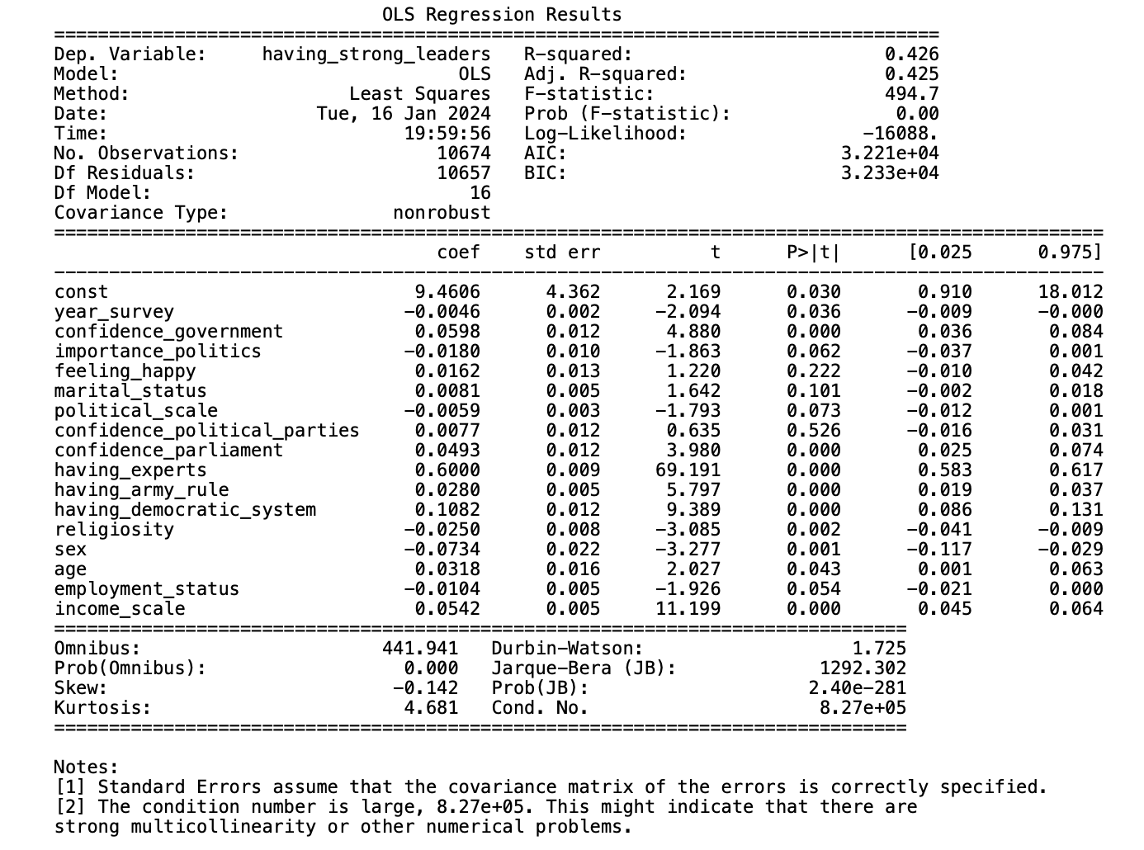**Having Strong Leaders**
2. **Having Democratic System**

metin, ekran görüntüsü, sayı, numara, yazı tipi içeren bir resim

Açıklama otomatik olarak oluşturuldu

1. **Having Army Rule**

metin, ekran görüntüsü, sayı, numara, yazı tipi içeren bir resim

Açıklama otomatik olarak oluşturuldu

1. **Having Expert Leaders**

metin, ekran görüntüsü, menü, sayı, numara içeren bir resim

Açıklama otomatik olarak oluşturuldu

1. **Having Democratic System (Religiosity and Political Scale Interaction Term is Added)**

metin, ekran görüntüsü, sayı, numara, paralel içeren bir resim

Açıklama otomatik olarak oluşturuldu

1. **Having Strong Leaders (Sex and Age Interaction Term is Added)**

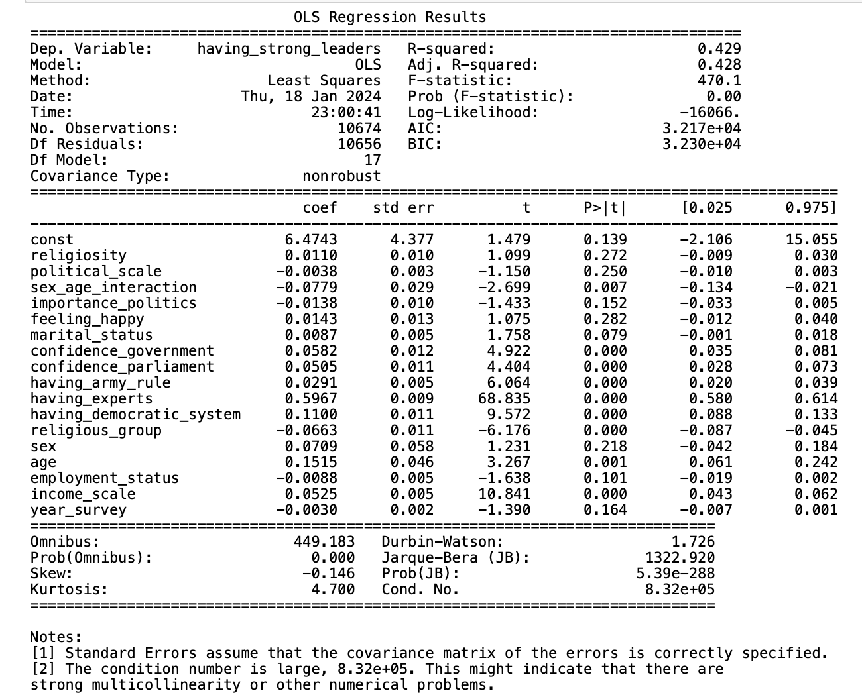

1. **Having Strong Leaders (Two Interaction Terms are Added)**

**metin, ekran görüntüsü, sayı, numara, yazı tipi içeren bir resim

Açıklama otomatik olarak oluşturuldu**

1. This is done mainly by the data visualisations.
2. This is done mainy by the regression analyses.
3. World Values Survey: <https://www.worldvaluessurvey.org/WVSDocumentationWVL.jsp>
4. Further information about Konda Barometer: <https://konda.com.tr/kondabarometre>
5. While the initial dataset is named as “data”, for the variables that both WVS and Konda have, a different dataset is formed named “consolidated_data”.
6. The dataset which missing values are excluded (and replaced with NaN) is named as “data_excluded_cells”.
7. Nancy Gina Bermeo, "On Democratic Backsliding," *Journal of Democracy* 27 (2016), 5
8. Samuel P. Huntington, The Third Wave: Democratization in the Late Twentieth Century. The Julian J. Rothbaum Distinguished Lecture Series, V. 4. Norman: University of Oklahoma Press, 1991, 16
9. Huntington, 27
10. Johannes Gerschewski, PEACE RESEARCH INSTITUTE FRANKFURT / LEIBNIZ-INSTITUT HESSISCHE STIFTUNG FRIEDENS- UND KONFLIKTFORSCHUNG. “AUTOCRATIZATION AND DEMOCRATIC BACKSLIDING: TAKING STOCK OF A RECENT DEBATE.” DEMOCRACY PROMOTION IN TIMES OF UNCERTAINTY: TRENDS AND CHALLENGES. Peace Research Institute Frankfurt, 2018, 6
11. Gerschewski, 5
12. Hakan Sönmez, “Democratic Backsliding or Stabilization? The Role of Democracy Indices in Differing Interpretations”. *Politikon: The IAPSS Journal of Political Science,* Year: 2020, 46 (September), 56-57; cited from Luca Tomini and Claudius Wagemann, Varieties of contemporary democratic breakdown and regression: A comparative analysis, *European Journal of Political Research*, 57: 687-716.
13. Bermeo, 6-7-8
14. Bermeo, 8-14
15. Sönmez, 70
16. Gerschewski, 9
17. Yascha Mounk and Foa Roberta, “The Danger of Deconsolidation: The Democratic Disconnect”. *Journal of Democracy* 27, no. 3 (July 2016), 8
18. Amanda Taub. 29 Nov 2016. ‘How stable are democracies? ‘Warning signs are flashing red’’ *New York Times.*
19. Norris, Pippa. “Is Western democracy backsliding? Diagnosing the risks”, *Harvard Kennedy School research working paper series no. RWP17-102*, Harvard University, 5
20. Annika E. Poppe, Solveig Richter and Jonas Wolff, PEACE RESEARCH INSTITUTE FRANKFURT / LEIBNIZ-INSTITUT HESSISCHE STIFTUNG FRIEDENS- UND KONFLIKTFORSCHUNG. “DEMOCRACY PROMOTION IN THE 21ST CENTURY.” *DEMOCRACY PROMOTION IN TIMES OF UNCERTAINTY: TRENDS AND CHALLENGES*. Peace Research Institute Frankfurt, 2018, 2
21. Pew Research Center, October, 2017, “Globally, Broad Support for Representative and Direct Democracy”, 3
22. Pew, 6
23. Pew, 8. For example; in UK, 42% think rule by experts and 26% think rule by strong leaders would be good for their country.
24. Pew, 10
25. Pew, 11
26. Pew, 20-22
27. Foa and Mounk, 8
28. Pew, 20-22
29. To repeat, the question about the religious system is not employed in the regression analyses because WVS and KONDA do not have similar independet varibles.
30. See Appendix: OLS Regression Results 1, 3, 4 and 5.
31. See Appendix: OLS Regression Results 1 and 3.
32. See Appendix: OLS Regression Results 1, 3 and 4.
33. See Appendix: OLS Regression Results 2.
34. See Appendix: OLS Regression Results 2, 3 and 4.
35. See Appendix: OLS Regression Results 7.